Williamson Driftriders Snowmobile
Club, Inc.
Official Club Bylaws Submitted February, 2020 - Adopted 3/02/21

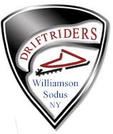

Table of Contents
Revision History......................................................................... , 3
Article 1 - Name and Purpose 4
Section 1- Club Name 4
Section 2 - Club Purpose 4
Article 2 - Membership 4
Section I - Membership Provisions 4
Section 2 - Membership Application 5
Section 3 - Membership Comunications 5
Section 4 - Newspaper Of Record 5
Section 5 - Member Resignation 5
Section 6 - Member Expulsion 6
Section 7 - Membership Age and Voting Rights 6
Section 8 - Gratuitous Memberships 6
Article 3 - Management 6
Section 1 - Management 6
Article 4 - Board Of Directors 7
Section 1 - Number Required, Officers and Term Lengths 7
Section 1a - Eligibility 7
Section 2 - Vacancies ..................................... , 7
Section 3 - Meeting Quorum ..Requirements: 7
Section 4 - Presiding Officer Vote 7
-
Section 5 Committees 7
Section 6 - Spending Limits 8
Article 5 - Officers 8
Section 1 – President 8
Section 2 - Vice President ...................................................................................................... , 8
-
Section 3 Secretary 8
-
Section 4 Treasurer 8
Section 5 - Officer Order Precedence 9
Section 6 - Board Of Director Expulsion 9
Article 6 - Fiscal Year and Membership Year 9
Section 1 - Fiscal Year ... .., 9
Section 2 - Membership Year 9
Article 7 - Meetings 9
Section I-Annual Meeting 9
Section 2 - Special Meetings """""'" 10
Section 3 - General Membership Meetings ........................................................................................................... , 10
Section 4 - Meeting Dates and Times 10
Section 5 - Board Of Director Decisions ..............................................................._ 10

Section 1 - Election Procedures ..........:............................................................................................. _ 10
Section 2 - Election Results Announcements....................................................................................................................................................................................................................................................... , 11
Article 9 - Amendments To The By-Laws 11
Section 1 - Atnendments To The By-Laws 11
Article 10 - Club Disbandment 11
Section 1 - Reason For Disbandment..................................................................................................................................................................... " 11
Section 2 - Special Meeting Announcement Requirement 11
Section 3 - Special Meeting Voting Requirement 11
Section 4 - Asset Disposal 12
Article 11 -Club Logo 12
Section 1 - Club Logo. 12
Article 12 - Club Web Page 12
Section 1 - Club Web Page 12

Revision History
Revision 5 Dated 12/15/2020

By-Law Committee
Michael Kellock Tim Woodhams Rod Spafford John Faulks Tim Gulick
Dated Apri1 25th, 2005

By-law Committee:
John Faulks Tim Gulick
Darlene Lombardo Jack Gligora Dick Cowley
Gus Herman

Revision 2 April, 2003
Revision 1 November 18, 1970

Williamson Driftriders Snowmobile Club, Inc. By-Laws Article 1 - Name and Purpose
Section 1 Club Name
The name of the club will be Williamson Driftriders Snowmobile Club, Inc.

Section 2 Club Purpose
The purpose of the Williamson Driftriders Snowmobile Club, Inc. is as follows:
Promote safe and responsible snowmobiling throughout our trail system and the
local area by education and the development of a safe and comprehensive trail system.
. Promote greater interest in snowmobiling in the Williamson/Sodus area and develop
additional trail opportunities for our citizenry and visitors alike.
. To improve the public image of snowmobilers by the safe, considerate and courteous use of trails as well as providing snowmobile safety courses to the community.
. To cooperate with local officials to develop mutually satisfactory rules for broader and safer use of snowmobile trails in the community.
. To develop a fraternal spirit among landowners, townships, businesses and law
enforcement personnel.
. To accomplish all club goals with the least amount of disruption to private property and the environment.
. To collect dues and or borrow money for the development and maintenance of snowmobile trail system, related projects and other activities that may be permitted by law.
Article 2 . Membership

Section 1. Membership Provisions
Membership in the club will be open to the general public.

Section 2. Membership Application
Applications for membership shall be made either in writing or on-line, addressed to:
Williamson Driftriders Snowmobile Club, Inc.
P.O. Box 761 Williamson, New York 14589
The secretary of the club will provide forms for membership. They will also be made available on the club website. The signature on the form is an agreement by the applicant to abide by the by-laws of the club. The Williamson Driftriders club membership is $30.00 a year for an individual or family; this includes you, your spouse/partner and any children 10-17. This includes the required New York State Snowmobile Association (hence forth as the NYSSA) club membership due at application. There will be allowances exemption to the NYSSA basic club membership dues if the applicant is alreadymmaeemmbbeerr of NYSSA and has a valid NYSSA ID number or the name of the other club, this be one that has mandatory NYSSA membership. The membership form shall haveloaacation to apply this exemption
information. If this exemption is applied then the dues requiredired at application shall be $25.00. Checks returned for insufficient funds submitted for the club dues shall result in an additional $25 charge.
There can be at the discretion of the Board of Directors additional membership opportunities in the NYSSA made available to our members on our membership form. These premium level memberships opportunities are done for the convenience of our membership and are not required, however if any premium level membership is chosen this shall be applied in lieu of the basic NYSSA membership.
The membership period shall coincide with the club's membership year.
All general memberships shall use the NYSSA membership system or theWilliamson Driftriders application.
Section 3 - Membership Communications
Members may receive communications from the club via the clubs website, emails, postal mail etc.

Section 4 - Newspaper Of Record
The Lakeshore News will be the official publication of record of the club.

Section 5 - Member Resignation
A member may resign from the club at any time upon written or verbal notice to the Board of Directors. No refunds of dues will be made.

Section 6 - Member Expulsion
A member of the club may be terminated by a majority vote of the Board of Directors for non-payment of dues or for any reason or conduct deemed detrimental to the stated purpose set up by the organization such as, but not limited to, recklessness, negligence, inappropriate behavior or careless use of trails on property maintained by the club.

Prior to termination, the member may request a hearing of the Board of Directors at a meeting to be scheduled at the convenience of the Board. The Board of Directors has the power to review each members status at the beginning of each season.

Section 7 - Membership Age and Voting Rights
One membership, over 18 years of age, shall constitute one vote. In the case of family memberships, ONE adult member listed on the membership application over 18 years of age shall be eligible to vote. 18 years of age constitutes a separate paying membership. A family membership shall be you, your spouse/partner and children ages 10 to 17. Children under the age of 18 will be required to get parental signature.

Section 8 - Gratuitous Memberships
All cooperating landowners who allow the use of their property as a part of the trail
system as well as individuals and business owners who have made donations of at least $100 annually will be offered a gratuitous membership. Any individual or business owner making a large contribution can be allowed multiple year gratuitous membership as deemed appropriate by the Board of Directors. Any gratuitous membership shall also be accompanied by a gratuitous membership in the NYSSA at the basic club membership level paid for by the club. The membership form shall have a location to apply a NYSSA ID Number or club name to exempt the club from the NYSSA basic dues if the recipient is already a member of the NYSSA through another club or on their own.

All landowner and gratuitous memberships shall use the Williamson Driftriders, membership application

Article 3 - Management

Section 1 - Management
The management of the club shall be vested in the Board of Directors.

Article 4 . Board Of Directors

Section 1 - Number Required, Officers and Term lengths
The Board of Directors shall consist of a minimum of seven people. Four of these directors will be the elected officers: President, Vice President, Treasurer, Secretary/Editor. These elected officers and Directors
shall serve a term of two years (President, Secretary and one director (director 2) will be elected on even years and Vice President, Treasurer and two Directors (Directors 1 and 3) will be elected on odd years. Nominations (March) will be open at the general meeting one month before the annual meeting and Elections (April) by the membership will be held at the appropriate annual meeting. The minimum age of a director shall be 18 years of age in accordance with Article 2, Section 5

Section 1 a - Eligibility - To be eligible to serve as a Director you must be a Primary
member in good standing for 2 consecutive years, To be eligible to be an Officer of the club you must be a Primary member in good standing for 4 consecutive years. A Primary Member (paying dues to NYSSA) through the Driftriders.

Section 2 Vacancies
In cases of vacancies occurring in the Board of Directors by reason of death, resignation, or otherwise, the remaining directors shall by majority vote, elect from the general membership a successor for the unexpired term.

Section 3 - Quorum requirements
At all meetings (Regular, Board of Director, Annual or Special) a majority of the Board shall constitute a quorum. If a quorum of 5 is not present, the presiding officer shall adjourn the meeting to another time. There are special quorum requirements if the meeting subject is club disbandment see Article 10.

Section 4 - Presiding Officer Vote
The presiding officer shall vote only in the case of a deadlock upon any vote by the general membership or the Board of Directors. His/her vote will constitute the final decision.

Section 5 - Committees
The Board of Directors, may at its discretion by the affirmative vote of the Board of Directors, appoint an executive committee of the Board to carry on any business that is necessary between Board meetings. The Board may appoint other club committees or may delegate such authority to the President. The Board of Directors shall have the power at any time to discharge any committee.

Section 6 - Non budgeted Spending Limits
Official committee chairpersons (and BOD members) shall have the power to spend $300 between
meetings of the Board of Directors. A report shall be made either in person or in writing to the Board at the next Board meeting. In the case of greater amounts needed, the following rules apply:
Up to $500 - approval of three (3) Board members Up to $1000 - approval of five (5) Board members
$1,000 and over - requires a vote of the general membership at a regular or special meeting and the recommendation of an appointed committee or Board member.
In any of the above cases, the money is accessed through the Treasurer and President.

Article 5 - Officers

Section 1 - President
The president will preside at all meetings of the club and the Board of Directors shall appoint needed committees, shall be member ex-officio of all committees and shall carry on those other responsibilities assigned to him or her by the by-laws, by the Board of
Directors and/or by the membership. He or she or an appointee shall appear on all bank accounts as well as the treasurer.
Section 2 - Vice President
The vice-president during the absence or incapacity of the president at both general and board meetings shall perform the duties and have the powers of the president.

Section 3 Secretary/Editor
The secretary shall keep all the club records other than financial including minutes of the meetings, roster of the meetings, maintain a current list of land owners, list of committees
and their members, and discharge all the usual secretarial functions of the office as required by the by-laws, the Board of Directors, and/or the membership. The Secretary shall compile all
required information necessary to publish the newsletter. The newsletter shall be published August to May and normally on a monthly basis.

Section 4 - Treasurer
The treasurer shall keep the accounts of the club and have charge of its funds. He/she shall keep all the club's funds (except petty cash) in a bank approved by the Board of Directors

Directors and in the name of the club, subject to withdrawal by checks or electronic means signed by either the treasurer or the designated signatory. The treasurer shall dispense funds as directed by the Board of Directors and/or the general membership. A treasurer's report shall be prepared for each meeting. He/she shall maintain a ledger for expenditures and accounts receivable.

Section 5 - Officer Order Precedence The above listed officers are in order of precedence and one of these officers shall preside over all official business at all meetings. This shall set the order of who shall fill in for the president in his or her absence as the presiding officer.

Section 6 - Officer/Director expulsion
Removal of a Board member or Director must be by a unanimous vote of remaining board members. Reasons for removal could include but are not limited to:
-Misappropriation of funds
-Misconduct as outlined for general club membership

Article 6 - Fiscal Year and Membership Year

Section 1 - Fiscal Year
The Club Fiscal year will commence on January 1 and end on December 31. .

Section 2 - Membership Year
The membership year will commence on April 1 and end on March 31st. All dues
submitted on or after April 1st will be credited to the next membership year.

Article 7 - Meetings
Section 1 - Annual Meeting
The annual meeting of the club shall be held at the April meeting to coincide with the fiscal year calendar. Written notice of the time and place of the annual meeting shall be prepared and distributed to the membership by the secretary at least ten (10) days prior to the annual meeting and communicated electronically via the club website and FaceBook pages according to the membership application. It is the members responsibility to notify the secretary of any changes of addresses. A quorum of the Board of Directors is required .

Section 2 - Special Meetings
Special meetings of the general membership or the Board of Directors may be called by the president giving 48 hours notice via electronic communications, of the time, place and purpose of such meetings to the general membership or Board of Directors as
appropriate. At such special meeting there shall be consideration only to such business as is specified in the notice of the meeting. Any member of the board may contact the president to call a special meeting and will not be denied the right of a meeting. A quorum of the Board of Directors is, required see Article 4 Section 3. There are special requirements if the subject is club disbandment see Article 10.

Section 3 - General Membership Meetings
Any formal action taken at any meeting of the general membership shall require a majority
vote of members present. A quorum of the Board of Directors is required see Article 4 Section 3. .

Section 4- Meeting Dates and Times
Regular meetings shall be held monthly from August to May, on the first Tuesday of the month at 7:00 p.m. at a location designated by the Board of Directors.
Section 5 - Board of Director Decisions
Any decision made by the Board of directors is binding on the general membership and not subject to review (with the exception of club disbandment (see Article 10).

Article 8 - Election Procedure
Section 1- Election Procedures
Elections for Officers and the Board of Directors will take place at the April annual meeting with nominations taken from the general membership at the monthly meeting prior to the annual meeting. Nominations will be taken from the floor and then seconded. Once all nominations for officers and board members have been made, the secretary shall make a written ballot at the meeting and dispense the ballots to all eligible voters (see Article 2 Section 7.) The votes will then be tabulated at the meeting by the President and Vice President if present, or any other Board member not up for election, and the results made public. Of those nominated, the nominee has the final word on their inclusion on the ballot.

Section 2 - Election Results Announcements
At the first meeting following the annual meeting the first order under new business, the president shall announce the newly elected board members. The newly elected members will also be announced on the next regular newsletter as well as the club website.
Article 9 - Amendments To The By-Laws

Section 1 - Amendments To The By-Laws
These by-laws may be amended by a majority vote of the members present at a regular or annual meeting of the club. Any such proposed amendment shall be presented to such meeting for consideration and shall thereupon be laid on the table until the next regular meeting of the club. Only after this one-month review period; can positive consideration be given to the amendment. A majority vote is required by those in attendance to amend and there shall be a quorum of the Board of Directors as stated in Article 4 Section 3.
For the purpose of this section one-month shall be defined as the period of time between regular meeting dates of the club, that is the first Tuesday of one month to the first Tuesday of the next.

Article 10 - Club Disbandment

Section 1 - Reason For Disbandment
If in the course of its endeavors it becomes apparent to the Board of Directors and/or the membership that the club can no longer feasibly exist for whatever reason, be it lack of enthusiasm or the realization of global warming, then the President shall call a special meeting of the entire membership.

Section 2 - Special Meeting Announcement Requirement
Electronic notice of the time and place of the this meeting shall be prepared and distributed to the membership by the secretary at least ten (10) days prior to the meeting and mailed according to the membership application information. It shall also be advertised at least 7 days in advance in the newspapers of record at that time.

Section 3 - Disbandment Meeting Voting Requirement
At this meeting there shall be a vote on a resolution to dissolve the club, for passage of this resolution it shall require a majority vote of 2/3's of the Board of Directors of record at that time and a 2/3's majority vote of the membership that attend this special meeting.

Section 4 - Asset Disposal
If it is the consensus of the above stated vote to dissolve the club, all assets shall be disposed of under the supervision of the Board of Directors. From these proceeds first all debts shall be paid in full and if there is any remaining balance, this balance shall be donated equally to the Williamson Volunteer Ambulance Corps, and the Sodus Ambulance Corps.

Article 11 . Club Logo

Section 1 - Club Logo
Below is the official logo of the Williamson Driftriders, Inc., This logo can and should be used on any letterhead, poster, advertisement or web page as deemed appropriate by the Board of Directors. Use of a logo other than of the logo below is prohibited.

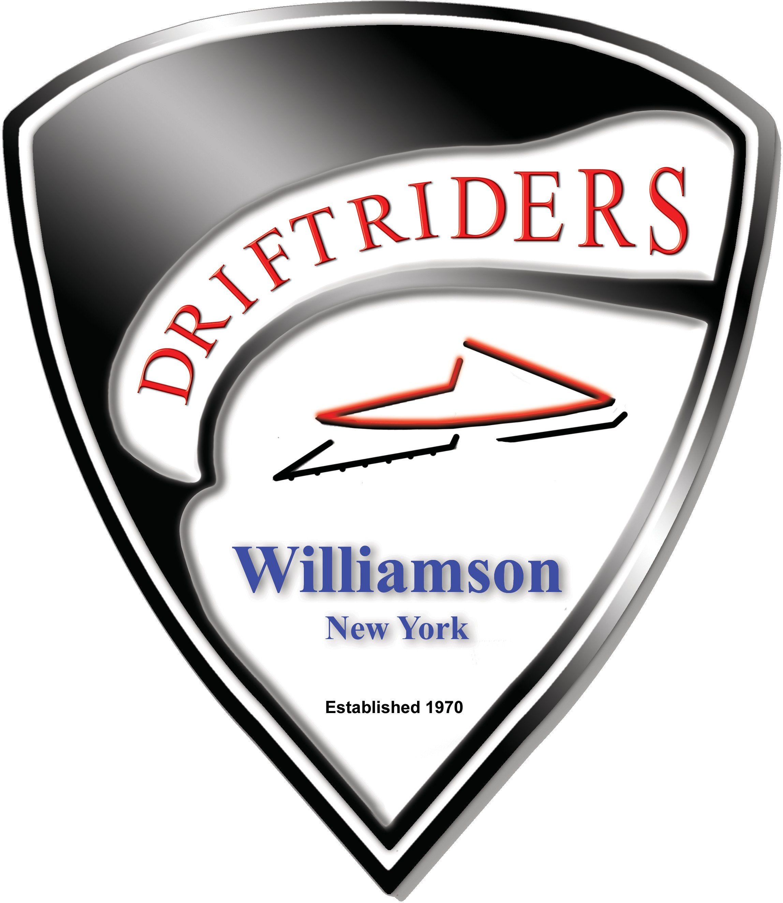

Article 12 . Club Web Page
Section 1 - Club Web Page
The official web page address of club is www.driftriders.com. This web site is to be used for the advertisement of club information and events. It can also be used to provide information on general snowmobile sports related activities and supporting business advertisements as deemed appropriate by the Board of Directors. At no time shall offensive material be placed on the web site. The web site shall be maintained by an individual appointed by the Board of Directors and shall be referred to as web master. The Board of Directors shall have final say on the content of the web site.

